**2022.02.03 Resonance in LCR Circuit**

**Start Time:** circa 09.00

Aim

An experiment was carried out to investigate resonance in a driven LCR circuit, by observing how the oscillator responds to changes in driving frequency, and peaks at the resonant frequency of the circuit. By plotting out the resonance curve for each of 1Ω, 2Ω and 3Ω, we will compare the theoretical value of the resonant frequency, to the value we obtain experimentally - when the driving frequency leads to a sharp increase in amplitude. Our theoretical value came out to be: 1/2π√(100×10¯⁹×10¯³) = 15916kHz. We will also calculate the quality factor and compare this to the theoretical values by using Python, and its curve-fitting algorithms to find ideal parameters in each of our functions that fit each respective curve.

Background

This experiment demonstrates behviour in a resonance curve for each of the systems. This LCR circuit is analogous to a damped mechanical oscillator - in fact, it is more or less its electrical equivalent. In a spring, this may be represented as the following:

**Equation 1:** relates the restoring force on a pendulum to its displacement from equilibrium position and the effect of damping on the system, where *F* represents restoring force, *k* represents the spring constant, and *b* is known as the viscous damping coefficient.

Rewritting the restoring force as a derivative of x, and applying an external force to the system to force the oscillator to oscillate, we arrive at the **Equation 2** for a damped, forced oscillator. As can be seen, this is a second order, inhomogeneous differential equation.

**Equation 2:** relates an external force to the derivatives of x, where F(t) is a time-dependent external force.

The amplitude of a driven harmonic oscillator, depends on how close the driving frequency is to the natural resonant frequency of the oscillator - the closer to this natural frequency, the more *resonance* (the sudden increase in amplitude) occurs. This amplitude is given by the following equation:

**Equation 3:** relates the amplitude, A, of an oscillation at certain angular frequency, ω with: A₀, the amplitude of the driving force; ω₀ = √(k/m) the resonant angular frequency; γ = b/m, which describes damping in the system.

We can also relate the phase difference between the driver and the driven oscillator. At high frequencies where (ω » ω₀), the oscillator and driver are out of phase, and this phase difference is given by **Equation 4**.

**Equation 4:** relates the amplitude, A, of an oscillation at certain angular frequency, ω with: A₀, the amplitude of the driving force; ω₀ = √(k/m) the resonant angular frequency; γ = b/m, which describes damping in the system.

The obtained plots that are fitted to **Equation 3** and **Equation 4** respectively should resemble the following graphs shown below:

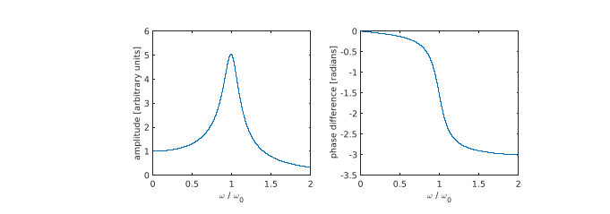

**Figure 1:** amplitude and phase for a forced oscillator, as function of frequency. *(Left:)* resonance curve following **Equation 3**. *(Right:)* phase shift curve following **Equation 4.**

Source: Mangles et. al (ed.), Imperial College London, 2021, “Year 1 Laboratory Manual Resonance”, pp.2

Similarly, the behaviour in an electrical circuit is analogous to that of a damped mechanical oscillator, where the inductor is analogous to the mass, the capacitor to the spring, and the resistor to the viscous damping.

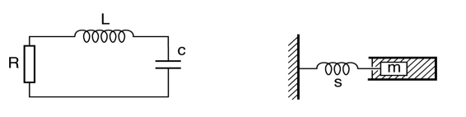

**Figure 2:** a comparison between an LCR circuit *(left)* and simple mechanical oscillator *(right)*.

*Source*: Mangles et. al (ed.), Imperial College London, 2021, “Year 1 Laboratory Manual Resonance”, pp.2

By Kirchoff’s voltage law in a closed loop, we arrive at the initial expression, where components are in series, as shown in **Figure 2**. We find that in a simple LCR circuit, the following expression is true:

**Equation 5:** relates total potential difference to the potential difference of the resistor, inductor, and capacitor in order of appearance.

Now, we can substitute the expression for each of the drops in potential difference across our respective components, assuming we have Ohmic behaviour across the resistor, we have:

**Equation 6:** relates total potential difference to each of the potential difference drops across the components, where V₀ represents the initial potential difference drop across the capacitor at time *t = 0*.

Taking the time derivative of the total voltage, and solving the integral, we arrive at the following expression:

**Equation 7:** relates change in total potential difference with inductor, resistor and capacitor

We can see that **Equation 7** is beginning to resemble the form of **Equation 2** with the damped harmonic oscillator - that of a second order inhomogeneous ordinary differential equation. Since we are interested in a driving force in this LCR circuit, where there is a sinusodial voltage signal, so in this case VT = V0 sin(ωt), we arrive at the **Equation 8**.

**Equation 8:** relates an external driving voltage to the derivatives of current.

It stands to reason that an LCR is the electrical analogue of a damped mechanical oscillator.

The quality factor (Q) of an oscillator describes the “sharpness” of peak in amplitude against the angular frequency, or more formally, energy stored in a circuit with its energy dissipation. Theoretically, we have that the Q factor for a given LCR circuit can be shown by the following:

**Equation 9:** theoretical quality factor in an LCR circuit, where ω₀ is the theoretical resonant frequency

Conversely, it can be shown that the Q factor can be determined experimentally by **Equation 10**. We seeek to compare the quality factor we obtain experimentally with our theoretical values in the *Data Analysis* section.

**Equation 10:** experimental quality factor in an LCR circuit, where Δω is defined as the width of a resonance curve, that is to say the distance in frequency between two points where the amplitude has decreased to 1/√2 its peak value.

This quality factor can be determined computationally using numpy by using a Numerical method to determine the peak, and the two points with 1/√2 of this peak.

To calculate our theoretical value of frequency, and by extension angular frequency, we make use of the following equation.

**Equation 11:** theoretical natural frequency, as related to the theoretical natural angular frequency, ω₀, as well as the inductance of the inductor, L, and capacitance of the capacitor, C.

Description of Set-up

In conducting this experiment, the following circuit as shown in **Figure 3** below, was reconstructed onto a breadboard, as shown in **Picture 1**. A two-way coaxial splitter was connected to both the signal generator output of the oscilloscope, and also channel 1 of the oscilloscope in order to observe the driving signal. From channel 2, we created a connection across the capacitor to measure the signal directly proportional to the charge on the capacitor.

**Figure 2:** a comparison between an LCR circuit *(left)* and simple mechanical oscillator *(right)*.

*Source*: Mangles et. al (ed.), Imperial College London, 2021, “Year 1 Laboratory Manual Resonance”, pp.3

In **Picture 1,** on the left, the following resistors correspond to the values:

|  |  |  |
| --- | --- | --- |
| **Top** | Brown Black Black *Silver* [Brown] | 1Ω ± 1% |
| **Middle** | Red Black Black *Silver* [Brown] | 2Ω ± 1% |
| **Bottom** | Orange Black Black *Silver* [Brown] | 3Ω ± 1% |

Our resistors correspond to resistances of (1 ± 0.01)Ω, (2 ± 0.02)Ω and (3 ± 0.03)Ω respectively.

**Picture 1:** *(left)* - the resistors used during the experiment. *(right)* - the breadboard set up based on Figure 2

In **Picture 1,** on the right, the components correspond to the following on **Figure 2,** with black wiring denoting *negative* and red wiring denoting *positive*: ORANGE - capacitor (C), BLACK - inductor (L), BEIGE - resistor (R). The following components have the values:

Reading off the tolerance codes, we have:

|  |  |
| --- | --- |
| **Inductor** | 1 mH ± 10% |
| **Resistor(s)** | (1 ± 0.01)Ω, (2 ± 0.02)Ω, (3 ± 0.03)Ω |
| **Capacitor** | 100 nF ± 10% |
| **Oscilloscope** | resistance: 1MΩ |

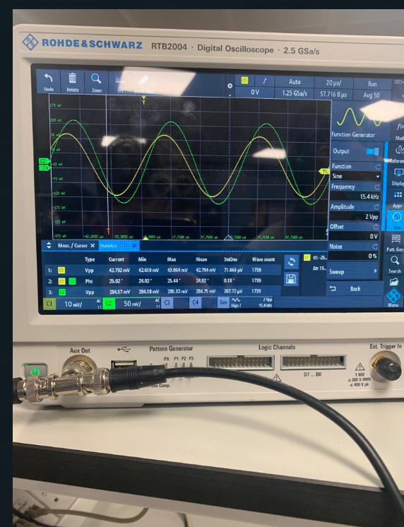

**Picture 2:** the co-axial splliter connected to Channel 1 (*right side)* and the other end of the circuit in parallel with the resistor to provide the driving frequency (*left side)*.

Measuring Strategy, Uncertainties

The values of phase difference and amplitude, as well as their respective standard deviations were measured at frequencies between 10kHz and 22kHz. Between 15kHz and 17kHz, smaller increments (typically 200Hz) were used to record more detail to account for the sudden increases of amplitude arising from the resonance peak. We decided this upon calculating the theoretical resonance frequency.

Having decided this, the oscilloscope was set up with a peak to peak frequency of 2V, and we adjusted the time base to an appropriate value to see several oscillations. Then, we turned on the “Statistics” menu, which we had set the “number of averages” taken to be 40. The mean peak to peak amplitude and phase difference was recorded for each value of frequency.

Upon recording this value, we changed the frequency on the signal generator of the sinusodial wave being produced, and clicked “reset statistics”, before taking our new readings. This was verified later as we took photos of each respective reading, such as the one shown above in **Picture 2**. All in all, close to 350 readings were taken.

**N.B**: unit of Vpp changes from mV to V when it exceeds 1V at resonant peak

|  |  |  |
| --- | --- | --- |
| **Top** | Brown Black Black *Silver* [Brown] | 1Ω ± 1% |
| **Middle** | Red Black Black *Silver* [Brown] | 2Ω ± 1% |
| **Bottom** | Orange Black Black *Silver* [Brown] | 3Ω ± 1% |

|  |  |
| --- | --- |
| **Inductor** | 1 mH ± 10% |
| **Resistor(s)** | (1 ± 0.01)Ω, (2 ± 0.02)Ω, (3 ± 0.03)Ω |
| **Capacitor** | 100 nF ± 20% |

The model of oscilloscope being used was the Rohde & Schwarz, RTB2004. The uncertainty in the time base of the oscilloscope was considered negligible.

Using **equation 9** and **equation 11**, we calculated our theoretical values of quality factor to be:

|  |  |  |
| --- | --- | --- |
| **Quality Factor (Q)** | 1Ω  (this is said to be underdamped) | 100.00 ± 11.22 |
| 2Ω  (this is said to be critically damped) | 50.00 ± 5.61 |
| 3Ω  (this is said to be overdamped) | 33.33 ± 3.74 |

taking into account the tolerances specified above. This was computed using the Python Uncertainties package, a very useful tool for error propagation.

*Documentation:* https://pythonhosted.org/uncertainties/

Data Analysis

The following data is recorded in **Table 1**, to show the phase difference, amplitude, and their respective standard deviations for each of a 1Ω, 2Ω and 3Ω resistor respectively taking at differing frequencies.

*Prediction:*

Predict decrease in quality factor as resistance increases.

Predict similar (ideally identical) values of ω₀ to be obtained for each of the three resistors.

Using the oscilloscope, the readings are the average of 40 different recordings, to give more precise data. An example of one such reading can be shown below:

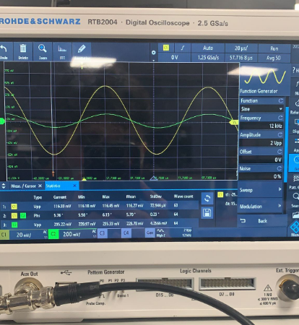

The following data, that was synchronously inputted into an Excel spreadsheet, is presented below:

|  |  |  |  |  |  |
| --- | --- | --- | --- | --- | --- |
| **Resistance/Ω** | **Frequency / kHz** | **Phase Difference / °** | **Phase σ** | **Amplitude/mV** | **Amplitude σ** |
| 1Ω | 10.00 | 5.18 | 0.37 | 64.54 | 0.45 |
| 11.00 | 5.88 | 0.22 | 71.96 | 0.76 |
| 12.00 | 6.52 | 0.21 | 82.01 | 1.21 |
| 13.00 | 8.71 | 0.31 | 102.06 | 2.14 |
| 14.00 | 11.36 | 0.35 | 132.71 | 3.71 |
| 15.00 | 17.84 | 0.59 | 205.50 | 8.51 |
| 15.20 | 20.85 | 0.45 | 242.61 | 3.31 |
| 15.40 | 24.92 | 0.19 | 283.47 | 0.72 |
| 15.60 | 28.74 | 0.35 | 322.84 | 5.06 |
| 15.80 | 38.85 | 0.91 | 403.59 | 6.08 |
| 16.00 | 47.74 | 0.12 | 475.01 | 0.18 |
| 16.20 | 63.51 | 0.33 | 551.07 | 2.05 |
| 16.30 | 76.72 | 0.29 | 590.49 | 0.11 |
| 16.40 | 84.97 | 2.00 | 594.36 | 5.09 |
| 16.50 | 96.09 | 2.10 | 592.51 | 1.59 |
| 16.60 | 111.90 | 0.12 | 547.42 | 9.57 |
| 16.80 | 126.54 | 2.20 | 508.00 | 8.09 |
| 17.00 | 141.00 | 0.74 | 420.68 | 5.24 |
| 17.20 | 149.40 | 0.71 | 353.69 | 5.31 |
| 17.40 | 153.34 | 0.73 | 306.69 | 6.70 |
| 17.60 | 158.88 | 0.43 | 262.89 | 4.59 |
| 17.80 | 162.29 | 0.47 | 225.37 | 4.09 |
| 18.00 | 164.96 | 0.33 | 198.28 | 2.73 |
| 19.00 | 171.62 | 0.23 | 123.66 | 1.09 |
| 20.00 | 174.75 | 0.30 | 93.10 | 2.28 |
| 21.00 | 176.81 | 0.31 | 66.60 | 1.41 |
| 22.00 | 178.48 | 0.39 | 54.58 | 1.37 |
| 2Ω | 10.00 | 4.13 | 0.13 | 124.25 | 216.84 |
| 11.00 | 4.17 | 0.08 | 135.51 | 1.80 |
| 12.00 | 5.89 | 0.10 | 162.08 | 1.75 |
| 13.00 | 7.57 | 0.26 | 195.74 | 5.06 |
| 14.00 | 11.03 | 0.07 | 273.84 | 0.11 |
| 15.00 | 17.55 | 0.28 | 408.15 | 7.89 |
| 15.20 | 19.95 | 0.35 | 462.05 | 6.60 |
| 15.40 | 23.57 | 0.47 | 530.88 | 8.20 |
| 15.60 | 28.40 | 0.60 | 612.05 | 11.35 |
| 15.80 | 35.22 | 0.92 | 709.88 | 12.96 |
| 16.00 | 38.93 | 4.14 | 752.33 | 43.86 |
| 16.10 | 58.40 | 0.23 | 936.80 | 2.25 |
| 16.20 | 68.15 | 0.91 | 976.06 | 4.69 |
| 16.30 | 76.54 | 1.37 | 991.41 | 3.79 |
| 16.40 | 88.14 | 1.09 | 1002.80 | 0.65 |
| 16.50 | 104.24 | 0.09 | 987.60 | 0.25 |
| 16.60 | 111.69 | 1.05 | 958.33 | 3.83 |
| 16.80 | 125.33 | 2.04 | 872.99 | 13.10 |
| 17.00 | 138.57 | 1.25 | 756.36 | 12.66 |
| 17.20 | 150.11 | 0.10 | 614.93 | 1.10 |
| 17.40 | 153.62 | 0.50 | 557.90 | 9.03 |
| 17.60 | 158.00 | 0.50 | 483.53 | 8.68 |
| 17.80 | 161.51 | 0.28 | 419.02 | 4.71 |
| 18.00 | 164.01 | 0.19 | 373.53 | 4.09 |
| 19.00 | 169.73 | 0.47 | 259.59 | 12.53 |
| 20.00 | 173.84 | 0.38 | 180.42 | 6.31 |
| 21.00 | 175.79 | 0.27 | 135.89 | 4.45 |
| 22.00 | 177.72 | 0.25 | 107.90 | 2.42 |
| 3Ω | 10.00 | 3.65 | 0.05 | 181.89 | 0.20 |
| 11.00 | 4.51 | 0.17 | 197.52 | 2.54 |
| 12.00 | 5.70 | 0.23 | 229.78 | 4.26 |
| 13.00 | 7.03 | 0.21 | 276.64 | 6.66 |
| 14.00 | 8.47 | 1.34 | 330.80 | 45.97 |
| 15.00 | 17.32 | 0.03 | 598.67 | 3.65 |
| 15.20 | 19.39 | 0.33 | 659.30 | 8.46 |
| 15.40 | 22.81 | 0.48 | 741.28 | 11.60 |
| 15.60 | 28.06 | 0.61 | 853.33 | 13.00 |
| 15.80 | 35.87 | 0.75 | 988.57 | 13.19 |
| 16.00 | 46.70 | 1.45 | 1121.00 | 16.35 |
| 16.10 | 57.88 | 0.61 | 1219.60 | 4.26 |
| 16.20 | 67.22 | 1.11 | 1264.00 | 5.07 |
| 16.30 | 77.71 | 1.49 | 1291.60 | 3.45 |
| 16.40 | 85.26 | 5.94 | 1298.00 | 3.56 |
| 16.50 | 103.47 | 1.26 | 1277.50 | 2.57 |
| 16.60 | 112.01 | 0.99 | 1244.30 | 4.64 |
| 16.70 | 121.47 | 0.93 | 1188.20 | 6.18 |
| 16.80 | 129.75 | 0.63 | 1120.30 | 5.18 |
| 17.00 | 138.34 | 1.28 | 1015.60 | 16.05 |
| 17.20 | 146.36 | 0.86 | 895.05 | 14.15 |
| 17.40 | 152.92 | 0.73 | 774.19 | 15.07 |
| 17.60 | 157.86 | 0.29 | 666.52 | 7.02 |
| 17.80 | 160.42 | 0.35 | 600.27 | 7.24 |
| 18.00 | 162.90 | 0.27 | 534.89 | 7.24 |
| 19.00 | 170.10 | 0.20 | 332.45 | 2.13 |
| 20.00 | 172.60 | 0.32 | 258.76 | 8.34 |
| 21.00 | 174.70 | 0.19 | 199.06 | 6.54 |
|  | 22.00 | 176.05 | 0.24 | 157.68 | 4.57 |

For all three resistors, our theoretical calculated value of the natural frequency was, ν₀ = (15.915±1.779) kHz, since the equation was not dependent on our values for R. This corresponded to an resonant angular frequency, ω₀ = (100000±11180) rad.s¯¹.

|  |  |
| --- | --- |
| Theoretical Natural Frequency | (15.915±1.779) kHz |
| Theoretical Natural Angular Frequency | (100000±11180) rad.s¯¹ |

**1Ω Resistor**

For the 1Ω resistor, the resonance curve, and phase difference graphs are as follows:

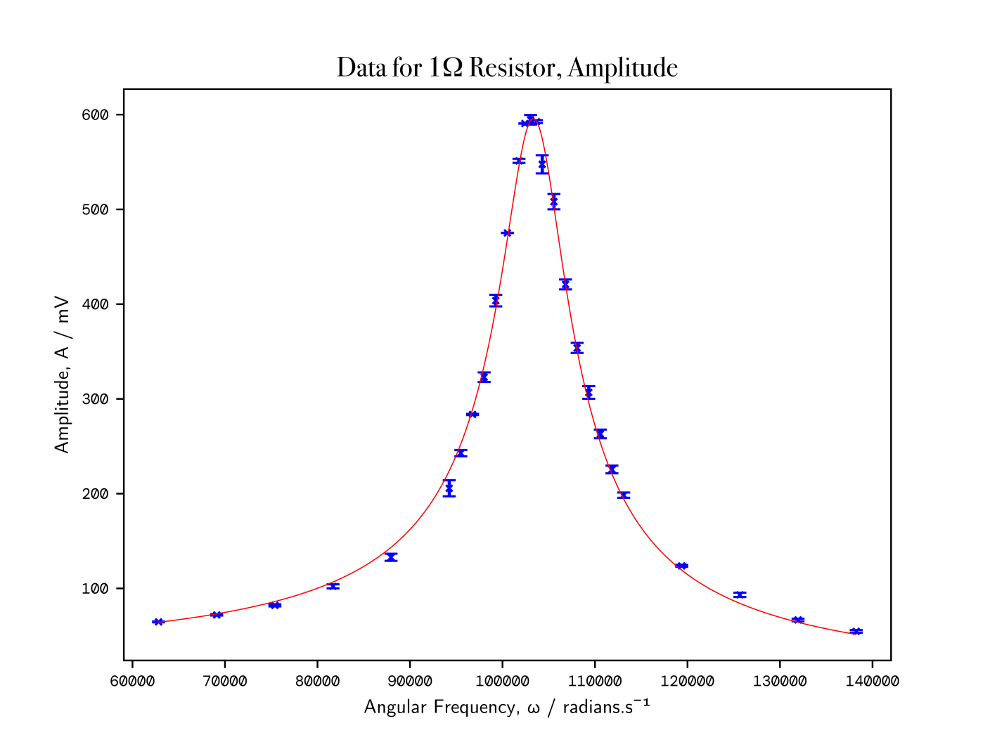

**Figure 3.1:** The angular frequency *(x-axis)*, ω, against the peak-to-peak voltage amplitude *(y-axis)*, A, for the 1Ω resistor. As can be seen, all the data lies in close proximity best fit curve described by **Equation 3**. Vertical error bars are shown.

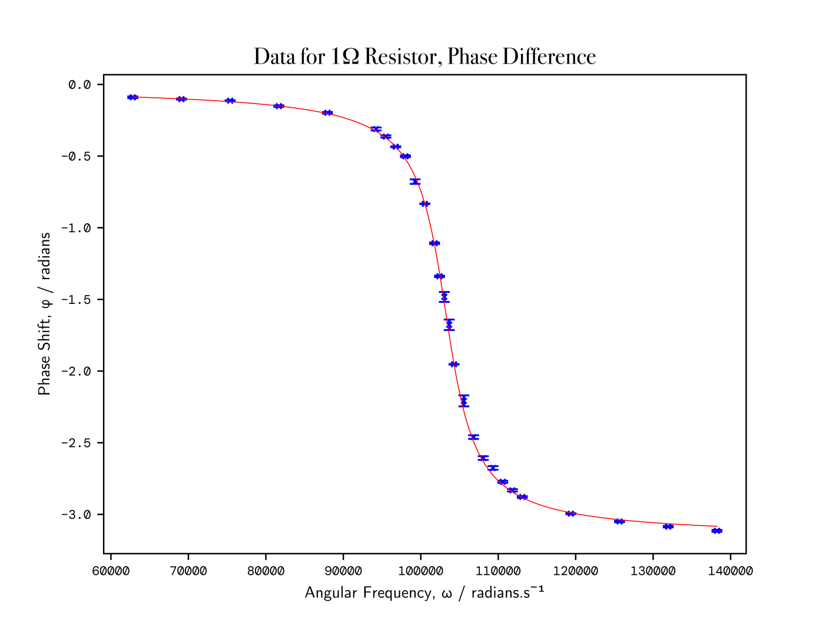

**Figure 3.2:** How the phase difference between *Channel 1* and *Channel 2* on the oscilloscope, φ, shown on the y-axis, varies over a range of angular frequency values (ω), shown on the x-axis, for the 1Ω resistor. The curve fits very tightly intercept all points on the graph.

The following data was obtained using the scipy curve_fit function, and we incorporated the displayed error bars into our curve-fitting function by setting the parameters of sigma, and absolute_sigma. Consequently, the standard deviation of each individual value was taken into account as part of the curve-fitting process, and by extension, the covariance matrix. The data for 1Ω resistor is as follows:

**Data for 1Ω Resistor, obtained from curve_fit parameters**

|  |
| --- |
| N = 434325571673.0895 ± 5734559217.098294  ω₀ = 103459.10360012094 ± 54.36104452755762  γ = 434325571673.0895 ± 124.19089258033851  Q (experimental) = 14.153253568409239+/-1.5823818540877266 |

**2Ω Resistor**

For the 2Ω resistor, the resonance curve, and phase difference graphs are as follows:

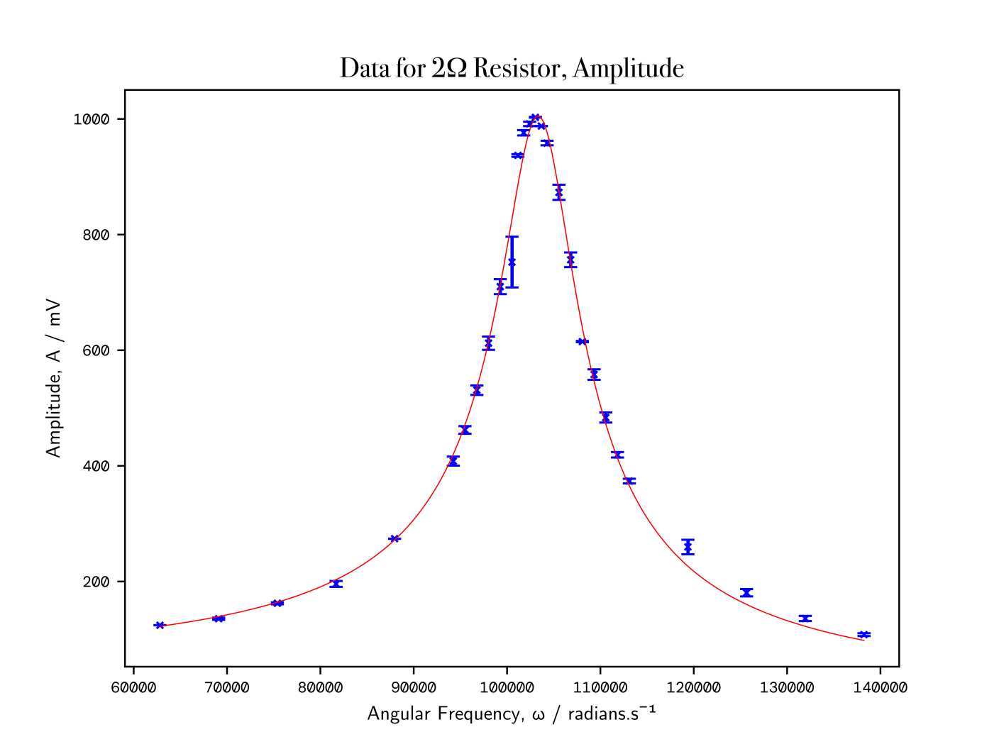

**Figure 4.1:** The angular frequency *(x-axis)*, ω, against the peak-to-peak voltage amplitude *(y-axis)*, A, for the 2Ω resistor. As can be seen, all the data lies in close proximity best fit curve described by **Equation 3**. Vertical error bars are shown. Note, the one data point around 100000 rad.s¯¹, has larger error bars. This is most likely due to more time elapsing before the reset statistics button was pressed.

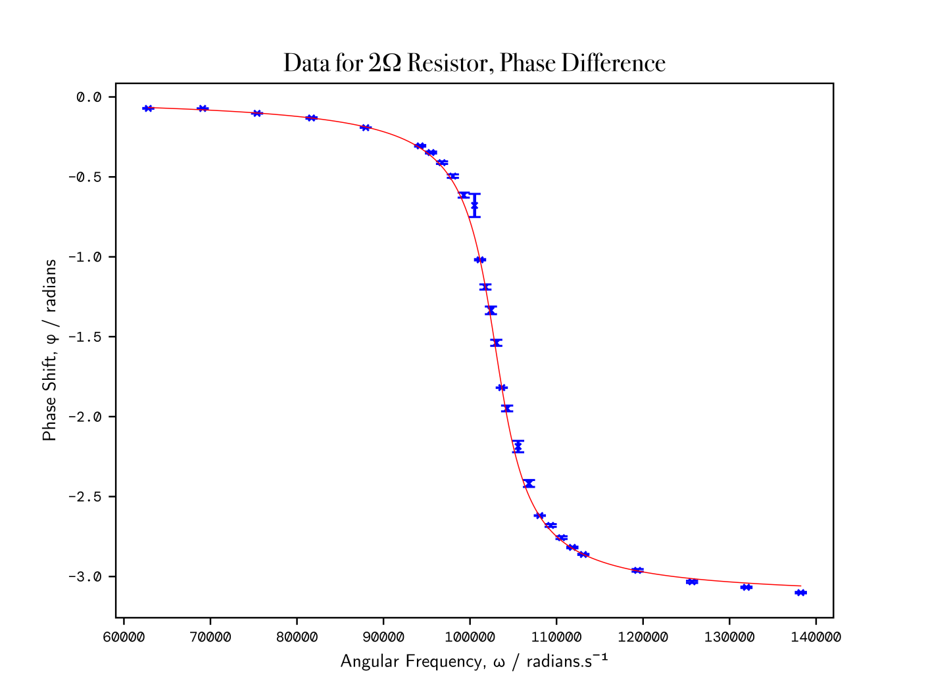

**Figure 4.2:** How the phase difference between *Channel 1* and *Channel 2* on the oscilloscope, φ, shown on the y-axis, varies over a range of angular frequency values (ω), shown on the x-axis, for the 2Ω resistor. The curve fits very tightly intercept most points on the graph. Note, the analogous point as mentioned on **Figure 4.1** with larger error bars, is an outlier of the curve.

**Data for 2Ω Resistor, obtained from curve_fit parameters**

|  |
| --- |
| N = 829924516593.9647 ± 15367849881.235281  ω₀ = 103481.88580695888 ± 79.78682548958096 rad.s¯¹  γ = 829924516593.9647 ± 195.86512173470834  Q (experimental) = 12.487380973257492+/-1.396131635857062 |

**3Ω Resistor**

For the 3Ω resistor, the resonance curve, and phase difference graphs are as follows:

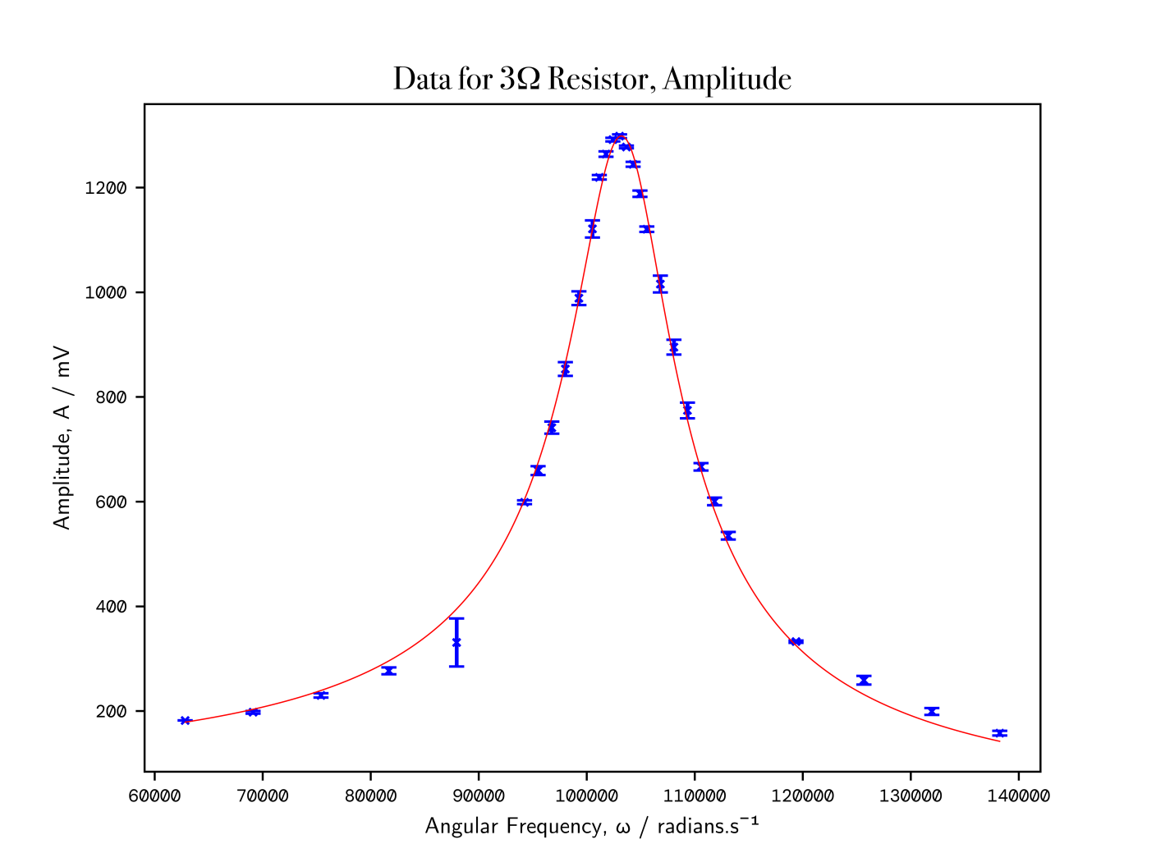

**Figure 5.1:** The angular frequency *(x-axis)*, ω, against the peak-to-peak voltage amplitude *(y-axis)*, A, for the 3Ω resistor. As can be seen, all the data lies in close proximity best fit curve described by **Equation 3**. Vertical error bars are shown. Note around 87000 rad.s¯¹, a similar instance to what occurred previously around 100000 rad.s¯¹, is visible, again as an outlier of the resonance curve.

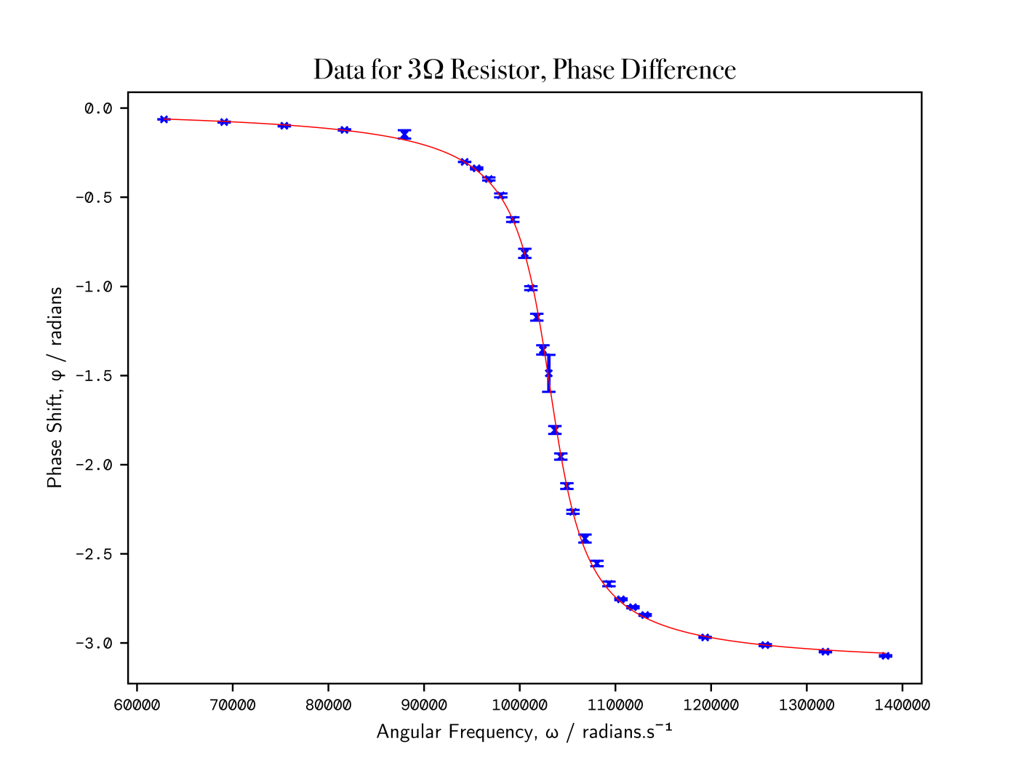

**Figure 5.2:** The angular frequency *(x-axis)*, ω, against the peak-to-peak voltage amplitude *(y-axis)*, A, for the 3Ω resistor. As can be seen, all the data lies in close proximity best fit curve described by **Equation 3**. Vertical error bars are shown.

**Data for 3Ω Resistor, obtained from curve_fit parameters**

|  |
| --- |
| N = 1208743436098.377 ± 16285238334.637613  ω₀ = 103405.7619498463 ± 61.476815364577874 rad.s¯¹  γ = 1208743436098.377 ± 156.7483019985262  Q (experimental) = 11.060549285737657+/-1.2366070035698071 |

Below is a summary of the data shown in **Figures 3-5**, as compared to the theoretical calculated values.

|  |  |
| --- | --- |
| Theoretical Natural Frequency | (15.915±1.779) kHz |
| Theoretical Natural Angular Frequency | (100000±11180) rad.s¯¹ |
| Experimental ω₀, 1Ω Resistor | (103459 ± 54) rad.s¯¹ |
| Experimental ω₀, 2Ω Resistor | (103482 ± 80) rad.s¯¹ |
| Experimental ω₀, 3Ω Resistor | (103406 ± 61) rad.s¯¹ |

Consequently, all our experimental values of the natural angular frequency, are within the range of each other, so are precise (as their uncertainty ranges exhibit significant overlap), but all deviate by roughly 3400 rad.s¯¹ from our theoretical value. However, they are all well within the uncertainty range of the theoretical natural angular frequency calculated. This matched our prediction that they would be similar.

|  |  |
| --- | --- |
| Theoretical Q factor, 1Ω Resistor | 100.00 ± 11.22 |
| Experimental Q factor, 1Ω Resistor | 14.15 ± 1.58 |
| Theoretical Q factor, 2Ω Resistor | 50.00 ± 5.61 |
| Experimental Q factor, 2Ω Resistor | 12.49 ± 1.40 |
| Theoretical Q factor, 3Ω Resistor | 33.33 ± 3.74 |
| Experimental Q factor, 3Ω Resistor | 11.06 ± 1.24 |

As resistance increases, it can be seen that there is a decrease in the quality factor, both theoretical and experimentally. Quality factor can also be thought to represent the ratio of energy stored to energy dissipated per cycle by damping processes. When we increase the value of resistance in the fixed resistor, the energy dissipated increases, and consequently the quality factor decreases.

Our data, however, in relation to the theoretical values, are well off. We expected to obtain values at least in the vicinity of 100, 50 and 33 for the 1, 2 and 3Ω resistors respectively. Instead, we arrived at quality factors between 11-14. This is indicative of our assumption that we are operating within an ideal circuit with no resistance in the wires, breadboard and capacitor, whilst we have infinite resistance in the inductor and oscilloscope (which in fact, had 1MΩ). This certainly cannot be assumed true, especially considering the fact that partway through our first set of readings, our breadboard refused to continue working, a problem that later had to be rectified through a new breadboard (and new set of wires as a precautionary measure), and we had to retake our set of readings for the 1Ω resistor. This threw into question the reliability of the breadboard and ideal nature of our circuit.

For a non-ideal circuit, this would result in a larger amount of energy dissipation per cycle: a factor which dictates quality factor. As expected, our quality factors were smaller than their theoretical values, by quite significant margins.

Summary

Consequently, we obtained from our resonance experiments in an LCR circuit, values for the natural angular frequencies as well as the quality factors, for each of a 1Ω, 2Ω and 3Ω resistor. We obtained resonance curves and phase shift curves from each of our readings of peak-to-peak amplitude, phase shift and their standard deviations for frequencies ranging between 10 - 22kHz. From here, the quality factor can be experimentally determined through the calculation of bandwidth computationally from the curve fits, as well as the peak from the tight curve fits to our data.

Our theoretical values for natural frequency were (15.9±1.8) kHz with an angular frequency of (100000±11180) rad.s¯¹, which compared to our experimental values of (103459 ± 54) rad.s¯¹, (103482 ± 80) rad.s¯¹ and (103406 ± 61) rad.s¯¹ for 1Ω, 2Ω and 3Ω resistors in the circuit, respectively. Our experimental findings were precise (with less than 0.5% deviation in values) and 3.4% off the theoretical value, but well within the error (0.31× the uncertainty range).

Our results for quality factor deviated significantly from the theoretical values: 100.00 ± 11.22, as compared to 14.15 ± 1.58, for the 1Ω resistor; 50.00 ± 5.61 compared to 12.49 ± 1.40, for the 2Ω resistor; and 33.33 ± 3.74 compared to 11.06 ± 1.24 for the 3Ω resistor. A lower quality factor than the theoretical value was expected as the theoretical value rests on the assumption that the circuit is ideal. Similarly, we expected the decrease in quality factor as resistance increases, however, our quality factors deviated far more than we were expecting. This suggests that many assumptions made in our model, such as the ideal circuit, are inaccurate; rendering the calculations far more complicated.

To improve upon the experiment, there would be several changes that would greatly increase both the precision, speed and accuracy of our results. More data would be obtained for each of the values of resistors, of which there would be a larger selection of resistors from which the data originated, such as smaller values of resistance < 1Ω which would give larger quality factors, as well as checking resistors of beyond 3Ω. Capacitors and inductors with smaller tolerances would be chosen, and that are as close to lossless, as well as low-resistance wires would be chosen. Otherwise, we could quantify (measure) the resistance of the wires and components, and include the resistance of the oscilloscope, 1MΩ, in calcuations. If there was a way to program the “Reset Statistics” button on the oscilloscope onto a mechanical button, this would have also made the data collection aspect of the practical more streamlined.